This are the editors found on my Joomla
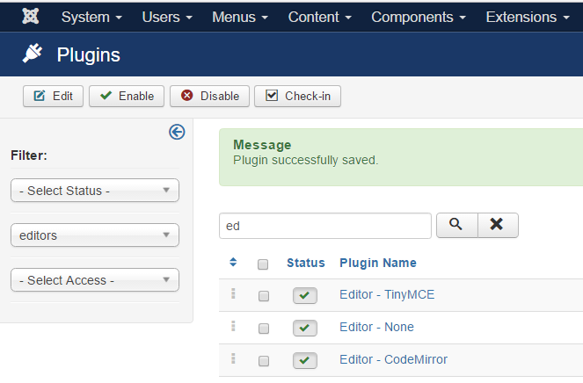
I enable iframe on TinyMCE

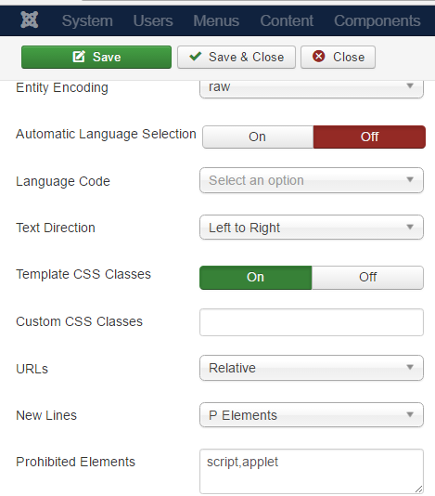
Default editor (TinyMCE ). Confirmed from global configuration
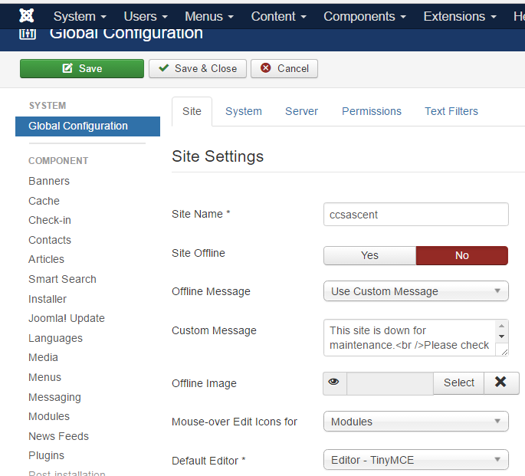

Text filter on global configuration not restricting super user
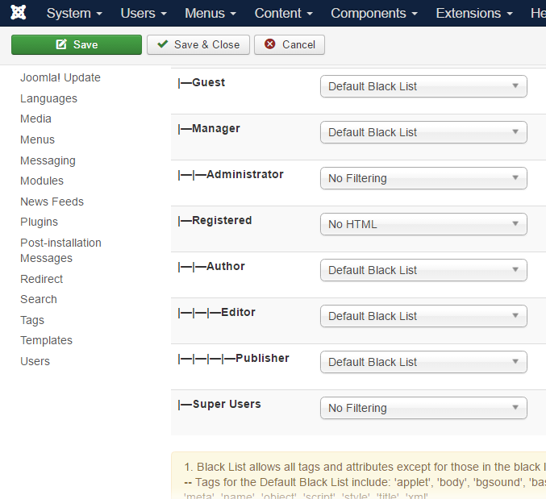

On quickstart template , Zentool menu→slideshow . This page has THREE video slideshow see below:
*Hence the saurce of my query. I want to find the iframe for this??????*
Therefore, I did following step to find where these three images are linked from.
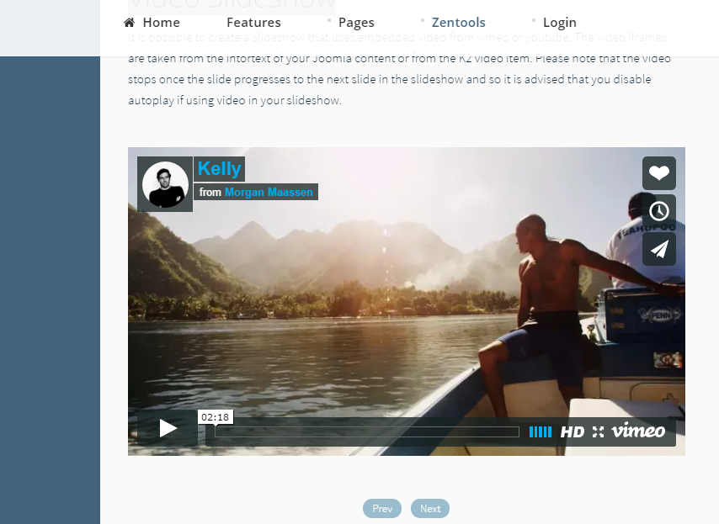

Step1: Slideshow in category has no html/iframe onTinyMCE which is what I expect.
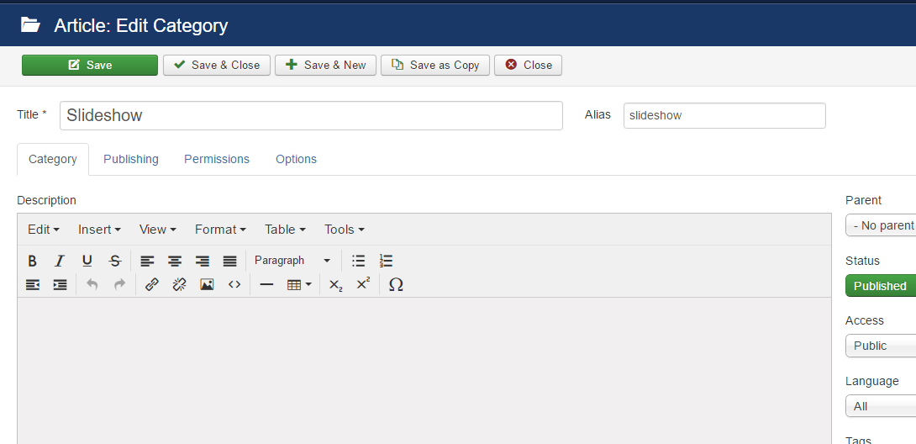

Step 2: Slideshow in article manager has following content video slideshow {loadposition slideshow-video}

Video Slideshow
It is possible to create a slideshow that uses embedded video from vimeo or youtube. The video iframes are taken from the intortext of your Joomla content or from the K2 video item. Please note that the video stops once the slide progresses to the next slide in the slideshow and so it is advised that you disable autoplay if using video in your slideshow.
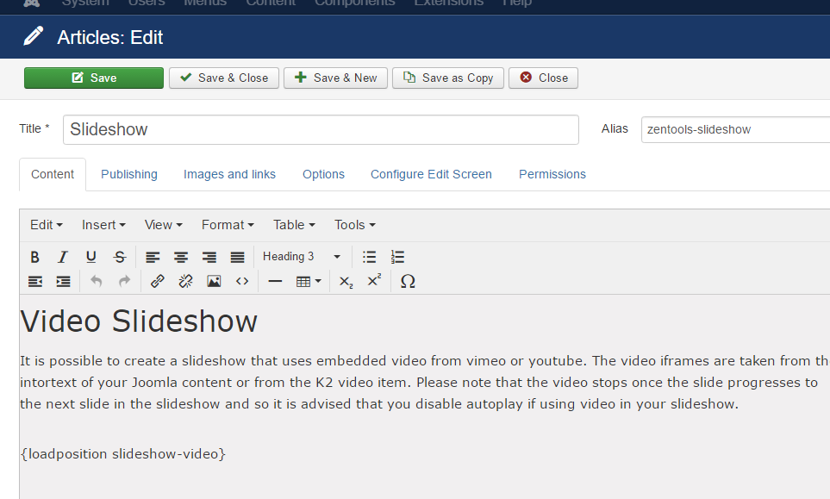

Step 3: I navigate through Slideshow Video on module manager. Module position (slideshow)
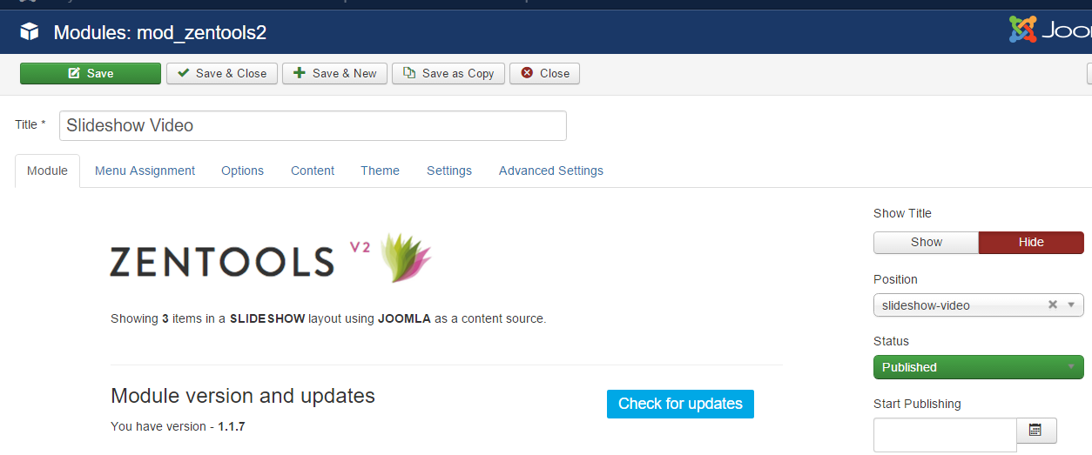

Option has video on drag and drop
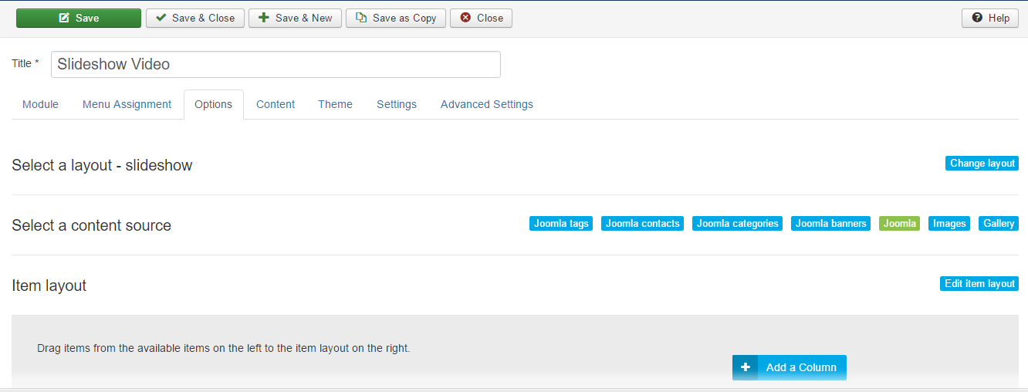
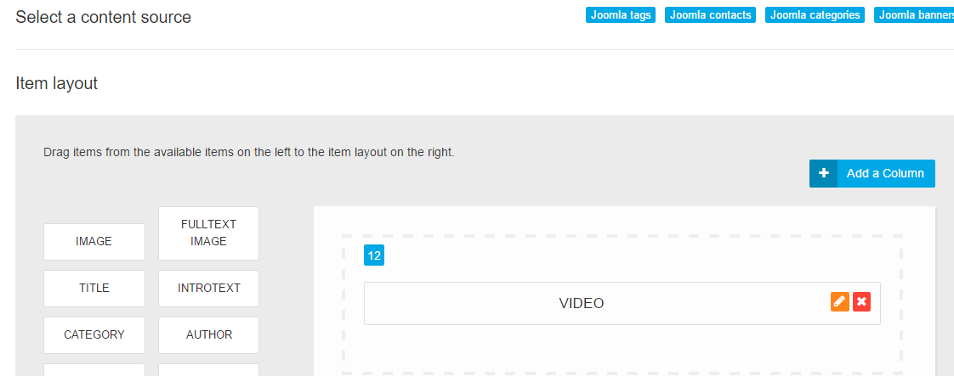

Content is set to select item from category and the category selected is video
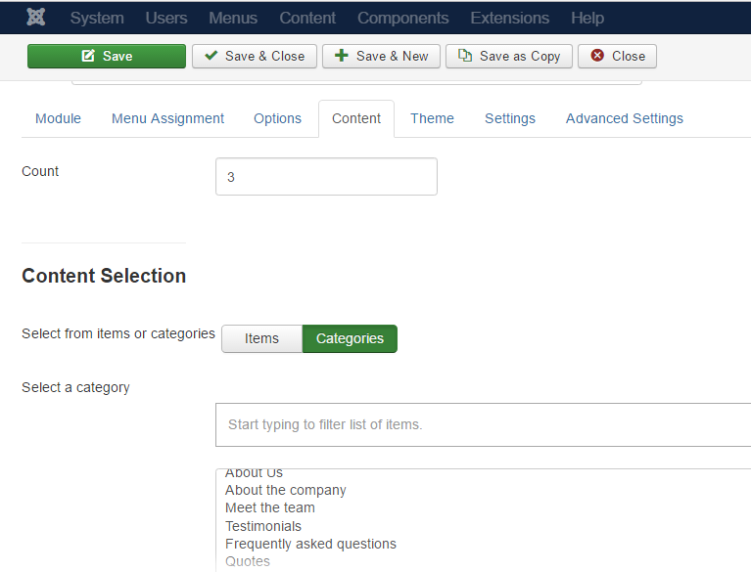
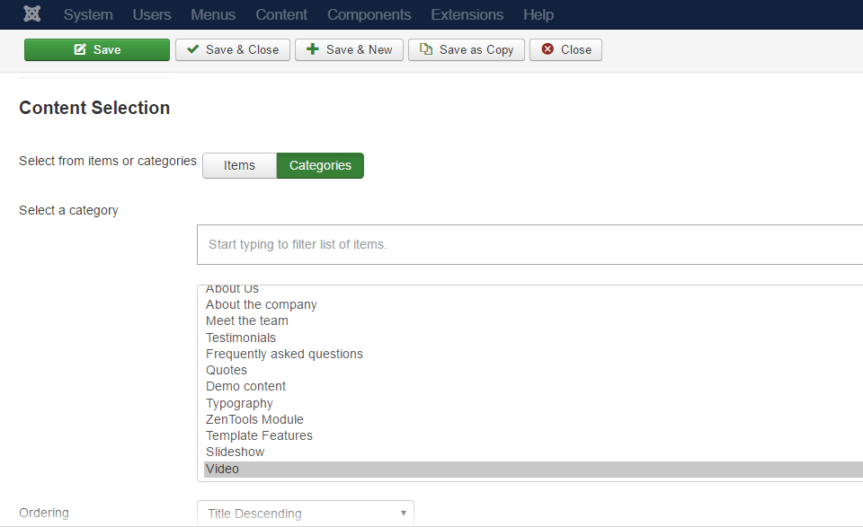

Big question is no Article video in article manager. The only video mentioned is category video from category manager.
As you can see below, there is No iframe or html found on video category.
So now,
*Where is the iframe for this video???
*Where is all of the ({loadposition xxx }) on my joomla Ascent2 quickstart???
*Say for example I want to change just ONE of the three slideshow video to a youtube video, Where can I edit??? Finding where to edit to chage video slide will resolve this question ☺
